**Product Roadmap**

**“Only Flights”**



Project Members & Student Numbers:

* Kaloyan Andreev (4408020)
* Francisco Marcó (4467752)
* Sava Vasilev (4663438)

Elaboration Date: 15/09/2022

**Table of content**

1. Product Roadmap 2

# Timeline Description automatically generated with medium confidenceProduct Roadmap

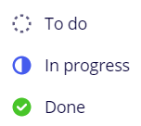

***Status of the tasks***

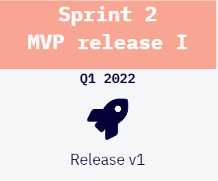

***Minimum Valuable product release version***

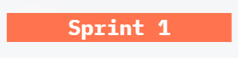

***Number of sprint***

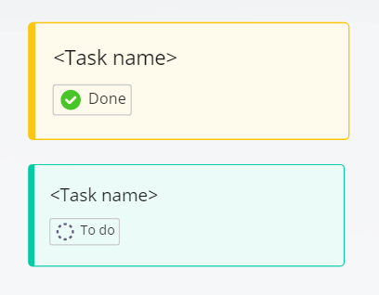

***Task***

